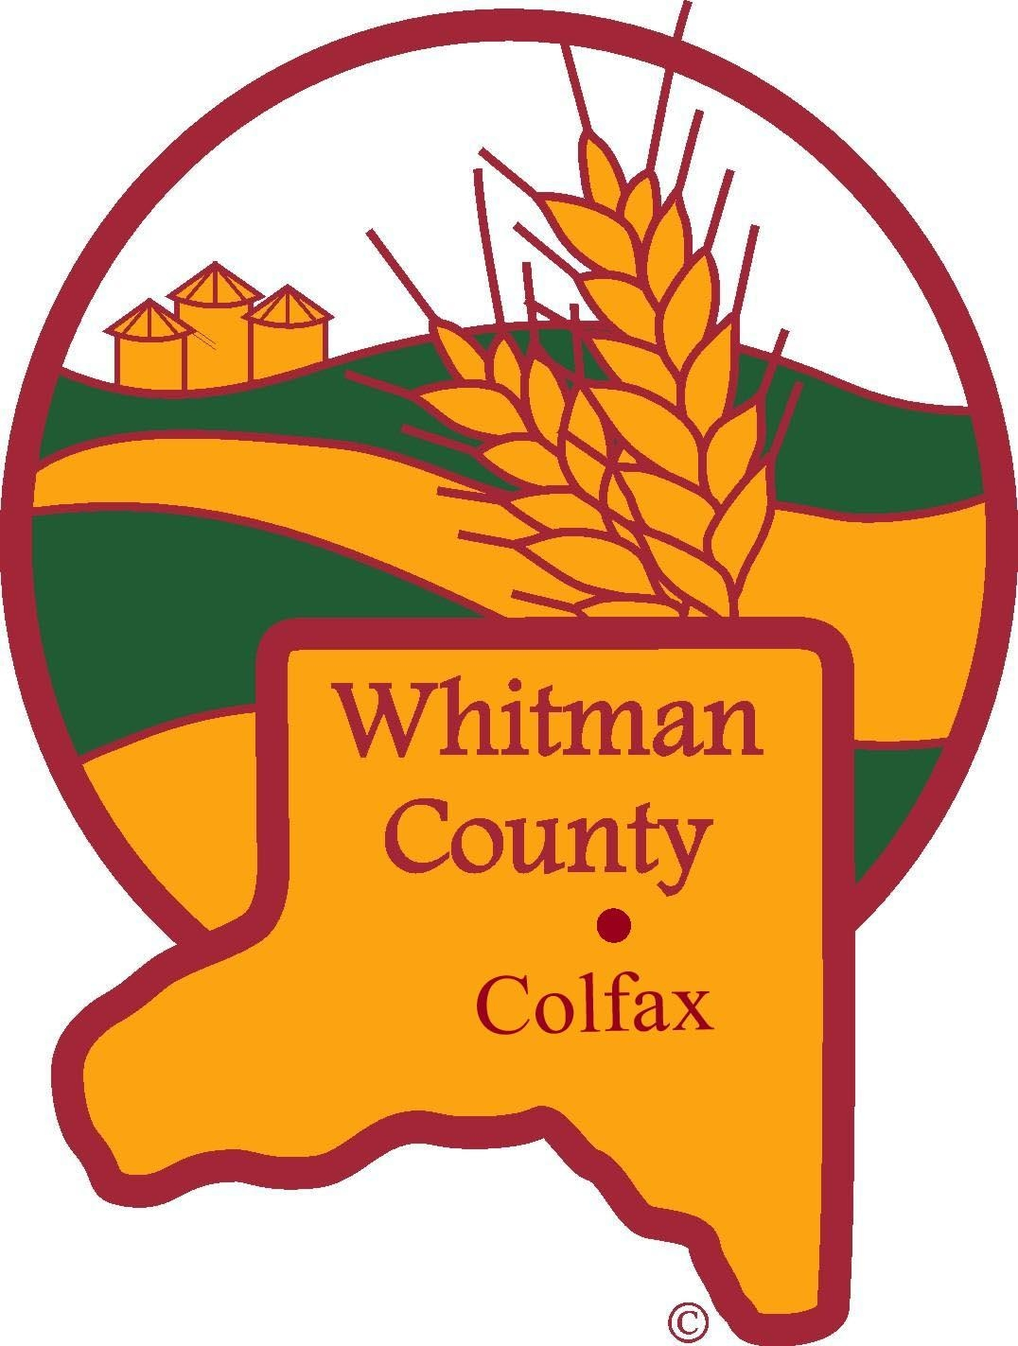

Whitman County Human Resources
Whitman County Courthouse
400 N. Main Street, Colfax, WA 99111

JOB ANNOUNCEMENT

POSITION: Community Health Educator

DEPARTMENT: Health Department

STARTING SALARY:

UNION STATUS: Courthouse Bargaining Unit – Initiation fees and monthly dues payment is required.

TO APPLY: Whitman County Human Resources
400 N. Main Street
Colfax, WA 99111
(509) 397-6205

CLOSING DATE: Open Until Filled

LOCATION: Colfax/Pullman

SELECTION PROCESS: Applicants must submit a signed Whitman County application form. The application will be reviewed and evaluated to determine applicants invited for an interview.

TO QUALIFY: See attached illustrative example of duties and requirements.

In compliance with the Immigration Reform and Control Act of 1986, Whitman County will hire only United States citizens and aliens authorized to work in the United States. Documented evidence of identity and employment eligibility must be presented at time of hire.

WHITMAN COUNTY IS A SMOKE-FREE WORKPLACE

EQUAL EMPLOYMENT OPPORTUNITY EMPLOYER

AMERICANS WITH DISABILITIES ACT

Persons requiring accommodation should advise of that need

WHITMAN COUNTY
POSITION DESCRIPTION

Effective Date:
Position Title: Community Health Educator
Job Family Classification # 13
Department Title: Health Department
Department Code: 280
FLSA Status: Non-Exempt
Union Status: Represented
Reports to: Director or supervisors

BASIC PURPOSE:
This is a position that carries out a variety of health service duties including: Coordinating activities and programs; Meeting state requirements for reporting and follow-up of notifiable conditions; Initiating direct client and partner contact to reach public health goals. This position will also be critical for the function of our clinical services arm. We are hoping to expand access to immunizations for vulnerable populations in Whitman County. It will also include the exciting work of helping with disease investigations and surveillance activities. There will be opportunities to participate in public health prevention and education activities.

NATURE OF WORK:
- Provide support to the disease prevention program, including disease investigations and data entry (60%).
- Conduct case investigations for notifiable infectious and communicable diseases.
- Administration of vaccines to adults and children during our weekly Community Clinics (30%).
- Provide additional support for offsite vaccine clinics when needed. There may be weeks throughout the year where more time will be allotted the administration of vaccines.
- Refer members of the public to community resources or other health department programs (10%). Acts as a Resource Navigator.
- Submits daily Communicable Disease data to the state.
- Provide back-up coverage of our front desk when needed.
- Participate in community meetings, staff meetings, and workshops as needed and related to the job.
- This position will work in both the Pullman and Colfax office.

ESSENTIAL FUNCTIONS:
Uses public health theories and processes to inform decisions.
Provides thorough program coordination.
Communicates daily with Epidemiologist and Vaccine Coordinator.
Participates in community meetings, presentations, and outreach activities that further identified public health goals.
Reports data to the state in various data-reporting platforms.
Assists in managing public health related grants to include application and reporting as needed.
Performs various office functions and fills in for other staff as needed.
Knowledge of community resources and public health programs.
Possesses excellent verbal and written communication skills.

NON-TECHNICAL ESSENTIAL FUNCTIONS:
Candidate must comply with organizational and departmental policies and regulations.
Candidate must possess a valid driver’s license and have a reliable vehicle.
Candidate must possess demonstrated ability to relate to individuals and families of varied ethnic and cultural backgrounds, ages, and economic circumstances.
Experience working with MS Excel and MS Word.
Experience working with Google Docs, Google Sheets, Google Form, and Google Slides.

SUPERVISION EXERCISED AND RECEIVED:
Supervision is not a normal responsibility of position in this class. Work is performed under the general direction of the Public Health Nurse with formal supervision from the Public Health Director.

SELECTION CRITERIA:
Knowledge, Skills, and Abilities:
Knowledge of: organization, function, and services of health agencies; social, health, economic problems of community served; report writing; public speaking; organizational skills; health education strategies; skilled in health assessment.

Ability to: work with clients and communities of diverse socio-economic and cultural backgrounds; communicate well orally and written; maintain confidentiality at all times; organize and present information and ideas clearly and effectively; work harmoniously with clients, the community at large, health/medical care providers, and the staff.

EXAMPLES OF DUTIES:
Administer vaccines and screen children for blood/lead.
Conduct notifiable conditions case investigation and complete all follow-up action items in a timely manner.
Efficiently report data to the state on a daily basis within WDRS and Sheldin.
Complete grant applications and all necessary reporting.
Update WCPH’s website to reflect current data and resources.
Work with community members to connect them to appropriate resources.
Helps coordinate vaccination efforts within the Public Health Department or between community providers.

QUALIFICATIONS:
Bachelor Degree in a health-related field and 2-3 years in a professional office setting preferred.
–or-
Associate of Arts Degree and 2-3 years of health education and services experience are preferred.
Education: Current MA certification in the state of WA.
Experience: Minimum 1-year experience in a clinical setting. Preferred experience with vaccinations and/or case investigations and resource navigation. Preferred skills: comfortable giving immunizations to pediatric populations.
Certifications: BLS
Other skills: Detail oriented, good with the public, able to communicate clearly and follow instructions, able to work independently and with support. A desire to be a part of a small but diverse team that works together closely to provide public health services to Whitman County. Possession of a valid driver’s license, a vehicle in good working order and be comfortable driving in inclement weather conditions.
WHITMAN COUNTY IS A SMOKE-FREE WORKPLACE
EQUAL EMPLOYMENT OPPORTUNITY EMPLOYER
AMERICANS WITH DISABILITIES ACT
Persons requiring accommodation should advise of that need

